Methods Summary: PAL1 & PAL2

General Design
- Instructional video preceding the execution of the task
- Practice list preceding the first experimental list
- 6 word-pairs per list; 25 lists per session; two sessions on consecutive days
- 10s countdown before the encoding phase of each list
- Encoding (~36s): 250 ms cross + 500-750 ms jittered blank + 4000 ms word pair + 1000 ms ISI
- Distractor (>=20s): A+B+C = ? math problems, where A/B/C are random integers 1-9
- Retrieval (~36s): 250 ms cross + 500-750 ms jittered blank + 4000 ms word cue + 1000 ms ISI
- Time on task for 25 lists/session: ~43 minutes

Task Schematic
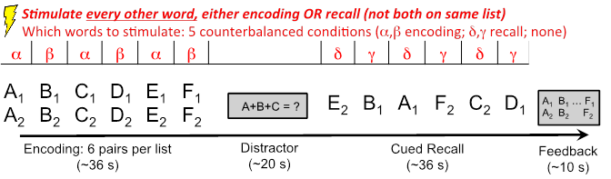

Word Lists
- The word pool is adapted from the word pool used in the pyFR task, which has been run in a set of over 150 intracranial patients (Burke et al., 2013; Long et al., 2014).
- A set of 300 words was chosen from the pyFR word pool, based on the recall performance of a separate set of participants who completed a large-scale study of free recall (24 sessions per participant). Recall performance in this large-scale task was modeled to estimate the effect of each individual word on recall, removing influences of serial position and frequency, concreteness, imageability and length. Estimates for the words were used to identify the words at the top and bottom of the distribution for removal.
- Word lists were constructed from the remaining 300 words according to an algorithm that generates unique lists with mean pairwise LSA similarity within list ~ .2.
- Word lists will be randomly assigned to stimulation conditions.
- All 300 words in the pool will be seen in a single encoding pair in Session 1, and then again in Session 2. The pairs and lists will be unique across Sessions 1 and 2.

Stimulation Parameters:
For the first cohort of participants, stimulation parameters (amplitude, frequency, and location) will be chosen to match stimulation from prior work showing stimulation-related enhancements in memory performance (Suthana et al., 2012). (Note: amplitude, frequency and location will be set manually by the clinician for System A).

Parameters fixed across first cohort of participants:
Stimulation amplitude: 1.5 mA (or 0.5 mA below afterdischarge threshold)
Stimulation frequency: 50 Hz

Parameters varied across participants based on electrode placement:
Stimulation location: entorhinal cortex or hippocampus (single site per patient)

Parameters varied within participant:
Stimulation timing: encoding and recall

Other Stimulation Parameters:
- Bipolar stimulation
- Pulse width: 300 microsecond pulse (150 us per phase)
- Duration: 4.6 s
- Inter-stimulation-interval during stimulation blocks: ~6 s

Timing of Stimulation:
- Stimulation will be applied during either encoding, recall, or not at all.
- Encoding and recall stimulation will occur on separate lists.
- Simulation will be applied during every other word (or word pair) in a designated stimulation epoch, starting with either the fist or second word of the epoch, counterbalanced across lists (see Task Schematic Figure, stimulation table in red)
- Stimulation will be triggered 200 ms prior to a word or word pair and will continue until 400 ms after word or word-pair offset (total of 4.6 seconds).

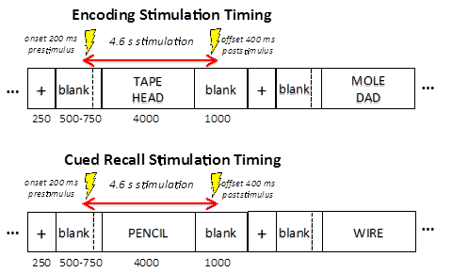

Assignment of Word List to Stimulation Condition:
- Out of the full set of 25 lists in a session: 5 lists will be assigned to the null condition--i.e. no stimulation for the entire list; 10 lists will be assigned to encoding stimulation; and the remaining 10 lists will be assigned to recall stimulation.
- The order of stimulation conditions (null; encoding; recall) will be randomized within and across sessions.
- The order of stimulation within a list (i.e. whether stimulation begins with the first or second word in a list) will be randomly assigned to each list, with the constraint that at the end of the session, half of the lists in each stimulation condition (encoding and recall) will have stimulation start on the first word.
- Lists in Session 2 are yoked to lists in Session 1 such that across two sessions, any word that is stimulated in one session will not be stimulated in session 2.

Experimental Design Power Analysis
● The experimental design shall be statistically powered to have at least a 90% probability of identifying a 10% increase in memory performance between the stimulation and no-stimulation conditions. This level of power will be achieved with N_{min}=11 subjects assuming 25 lists/session and 2 sessions per subject.
● Our power analysis estimates likelihood of detecting an overall difference in performance between stim and no stim trials. The probability of recalling a given word in the no-stim condition was modeled as a binomial distribution with p = 0.5, and the stimulation condition was modeled with a 10% increase in performance (binomial p = 0.6). Random draws from these binomial distributions were simulated based on the number of trials per patient (60 trials per condition). This process was repeated 1000 times for a range of 1 to 50 patients, and the proportion of t-tests that detected a significant difference between the conditions was used as the estimate of the design’s power.

References

Burke JF, Zaghloul KA, Jacobs J, Williams, RB, Sperling MR, Sharan AD & Kahana MJ (2013). Synchronous and asynchronous theta and gamma activity during episodic memory formation. Journal of Neuroscience, 33(1), 292-304.

Long NM, Burke JF & Kahana MJ (2014). Subsequent memory effect in intracranial and scalp eeg. NeuroImage, 84, 488-494.

Suthana N, Haneef Z, Stern J, Mukamel R, Behnke B, Knowlton B & Fried I (2012). Memory enhancement and deep-brain stimulation of the entorhinal area. New England Journal of Medicine, 336, 502-510.

